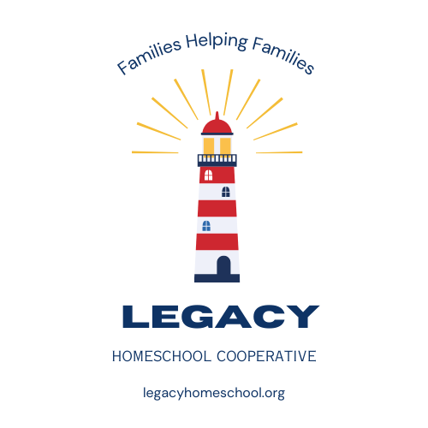
ABOUT US

Our Vision:
At Legacy, we honor traditional family values. We love God and we love others. We look to God for direction in our lives as individuals, as families, as communities.
As homeschooling families, we are coming together in friendship and learning. To achieve this goal, parents work together to create a variety of classes and activities. We believe there is value in many philosophies of learning and curriculum. We strive to enhance, not replace what we are learning in our individual homes, as we are stewards over our own families.
Our Lighthouse Symbol: At Legacy, we strive to be like a lighthouse. A place of safety, strength, hope and direction. We can help uplift and encourage each other by sharing our light!
Our Legacy: We honor the Legacy of our families, mentors, pioneers and our country's Founding Fathers. In them we find inspiration, wisdom and values to help guide our children and leave our own Legacy.
Member Information:
-We meet at the Whittier Center on Mondays
*Eligibility: Must have one or more 12–18-year-old children in your family attending to join or teach teens. Once our Navigator (teen) group is filled, we will open membership to families with just younger children.

All will:
1. Teach in a class on a rotational or team-teaching basis.
2. Abide by all policies and procedures.
3. Follow all standards of conduct.

THE LEGACY CREW

OUR LEADER”SHIP”- CAPTAIN: Emily Stoker
FIRST MATES: Kristine Atwood, Janel Brimley
GUIDES: ALL parents/teachers
NAVIGATORS: Ages 12-18
(Can be 11 turning 12 this school year- September-April, if ready for teen classes)
EXPLORERS: Ages 8-11
JR. EXPLORERS: Ages 4-7
LITTLE LIGHTS: Ages 0-3

Meet Emily:
I grew up in the Pacific Northwest where I found my love for nature, but not my love for education. In my heart, even as a child who struggled in school, I knew there was a different way to learn. When my oldest child was in 6th grade and in public school, it was time to find that “different” way. We started our homeschooling journey and never looked back! We have been homeschooling for the past 11 years. We have two children who have graduated from homeschooling and three at home. I have discovered that gaining knowledge comes in many ways. There isn’t only one way to learn, one curriculum, or one philosophy. We love that we can learn and grow in our own way with endless possibilities!
We are blessed to be part of the Cache Valley homeschool community! We have thoroughly enjoyed putting on teen dances and events for the past 5 years and will continue to do so. Since starting our homeschool journey, I have loved teaching a variety of classes at co-ops and educational groups. While these groups have been great experiences among wonderful people, our family was missing something, a feeling of “family” outside of our own. This inspired me to create Legacy Cooperative in the traditional “family style”. From past experiences, I know family co-ops not only work but thrive! It is so exciting seeing families coming together to socialize and to learn from each other. When families support each other and work as a team, inspiration comes, and amazing things happen! I feel blessed to be a part of this Legacy.
Meet Kristine:
I grew up in Tallahassee, Florida. I am the oldest of 8 children and loved being in a big family and always loved kids. I went to public school and got straight A's (including through college) and was valedictorian of my high school- but I never found anything I was passionate about- all I knew how to do was do school. I went to college to be an elementary school teacher and was certified to teach K-8. During my student teaching was when my first desires to homeschool came because I didn't like what I saw in the school system. When my oldest child was kindergarten aged, I was too scared though, so I put him in public school and he hated every minute, so I decided that we would homeschool and I have ever since. I have now been homeschooling my 5 kids for 8 years.
We love homeschooling and the freedom to learn, explore, develop at a speed that fits each individual in our family and spend more time as a family. We have homeschooled in several states and love Cache Valley and the homeschooling environment/community here. We love being part of the Legacy Co-op community and all the wonderful relationships we've built here!

Meet Janel:

Coming soon!

LEGACY CLASSES
To understand the Legacy left by our ancestors, and the cultures that shape them, is to understand ourselves better and continue the Legacy. We believe there is value in learning from other cultures and people of the past, their struggles and successes, along with their creativity and ingenuity. Learning from the past can help us create a better future. At Legacy, we follow a four-year timeline rotation: Ancient Times, Middle Ages, Colonial Period, Modern Era. Our children will be able to explore many topics within these timelines with our “Compass of Learning” as their guide. Navigators and Explorers become Inventors, Seekers, Artisans and Adventurers for the day!
*The timeline may not be applicable in some classes.
Our desire is that Guides aid in helping our children Navigate and Explore a variety of topics in our classes.
Classes are created by Guides and must be approved by Legacy Leadership to make sure it aligns with Legacy’s Vision and Policies.
We believe there is value in many philosophies of learning and curriculum. Therefore, it is not required to follow one particular curriculum.
Our goal is to create engaging, interactive classes while keeping lessons simple.
Guides rotate teaching or team teach in 14-week semesters.
Our classes are split into age groups: Navigators, Explorers, Jr. Explorers, Little Lights.
*A Little Lights class is contingent on available classroom space and Guide availability. Otherwise, Little Lights will need to stay with their parent. It is their parents' responsibility to provide all that is needed for the child for co-op day.

OUR COMPASS OF LEARNING

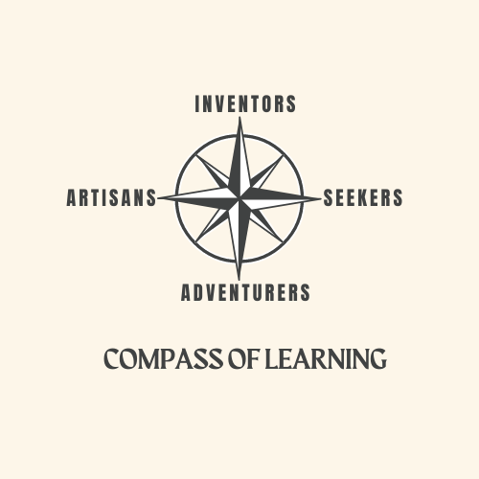
We have listed some examples of possible class topics. There are many more possibilities, and many can fit in more than one compass points.

Inventors: Science, Tech, Math, Engineering, Architecture, Robotics, Business, Lego or Building Challenges, etc.

Seekers: History, Geography, Writing, Constitution, Debate, language, Literature, Sociology, Life Skills, etc.

Artisans: Arts & Crafts, Drama, Sewing, Music, Cooking, Painting, Drawing, Photography, Interior Design, etc.

Adventurers: PE, Health & Fitness, Dance, Survival Skills, Board Games, 4-H, etc.

LEGACY DEVOTIONAL (before lunch)

Devotional is an important part of Legacy Homeschool Cooperative. This time is devoted to keeping informed with important co-op announcements, getting more acquainted, sharing our talents, and encouraging each other, through thoughts, prayer, and the Pledge of Allegiance. We encourage each family to take a turn each week to share a thought, prayer and lead the Pledge of Allegiance.

LUNCH
At Legacy we eat together as families either in the gym area or outside. Pizza is available for purchase during lunch for those who would like. Each person will receive 2 slices of pizza and salad for only $2.

LEGACY ACTIVITES

Legacy has optional activities for the whole family outside of co-op day that are planned by parents and Navigators. They vary from year to year depending on the needs of members.

School Year: Sep. 2025- April 2026- “Ancient Times”
September 8- Fall semester begins
December 8- Last day Fall semester (14 days of classes)
January 5- Spring semester begins
February 16- Winter break
March 30- Spring break
April 20- Last day Spring semester (14 days of classes)

